1.

#include <iostream>

using namespace std;

int main() {

int num1, num2;

cout << "Enter two integers: ";

cin >> num1 >> num2;

cout << "Addition: " << num1 + num2 << endl;

cout << "Subtraction: " << num1 - num2 << endl;

cout << "Multiplication: " << num1 \* num2 << endl;

if (num2 != 0) {

cout << "Division: " << num1 / num2 << endl;

cout << "Modulo: " << num1 % num2 << endl;

} else {

cout << "Cannot perform division and modulo as the second number is zero." << endl;

}

return 0;}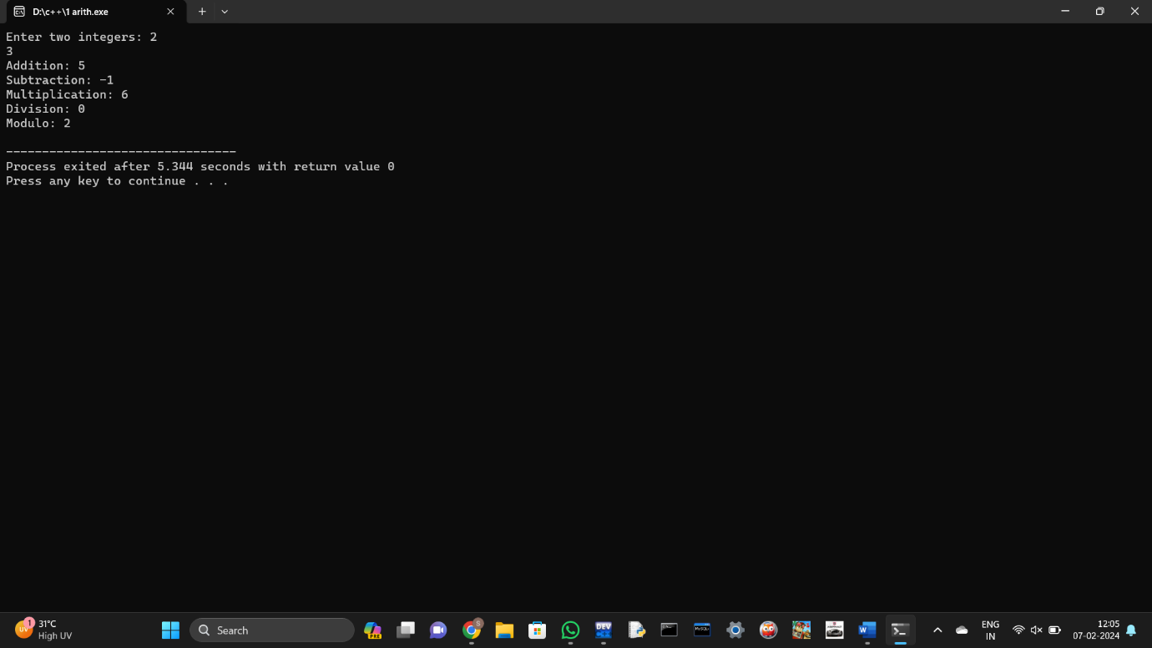

2.

#include <iostream>

using namespace std;

int main() {

int num;

cout << "Enter an integer: ";

cin >> num;

if (num % 2 == 0) {

cout << num << " is even." << endl;

} else {

cout << num << " is odd." << endl;

}

return 0;

}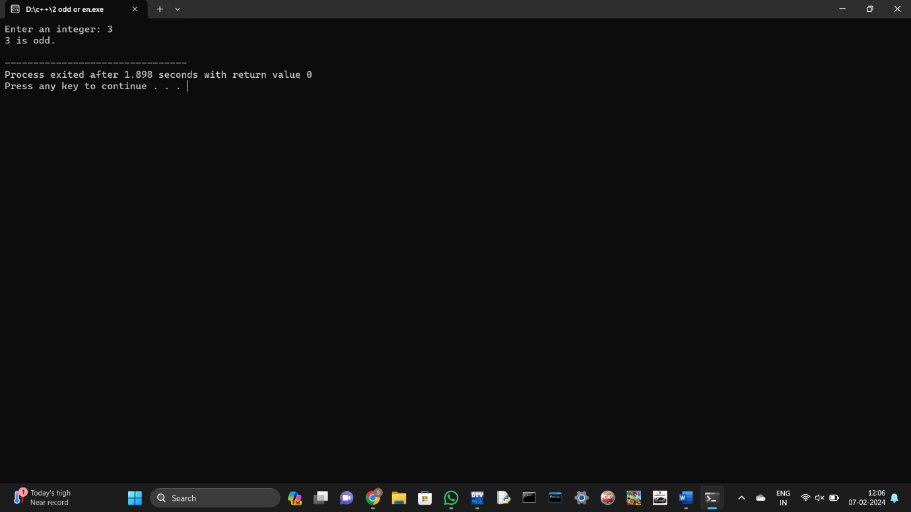

3.

#include <iostream>

using namespace std;

int main() {

int num1, num2, num3;

cout << "Enter three integers: ";

cin >> num1 >> num2 >> num3;

double average = (num1 + num2 + num3) / 3.0;

cout << "Average: " << average << endl;

return 0;

}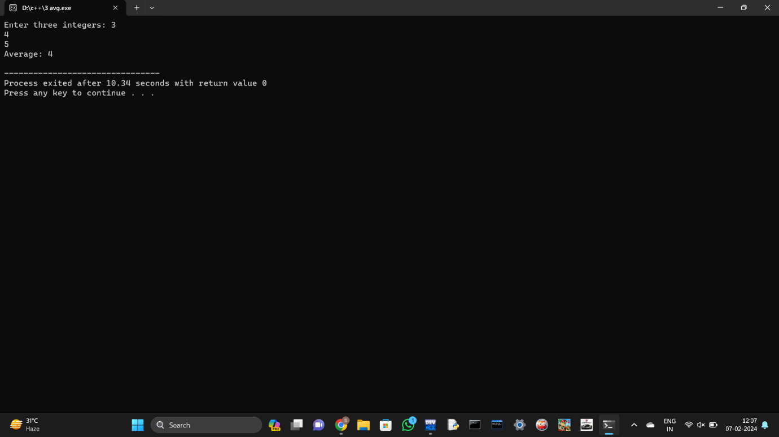

4.

#include <iostream>

using namespace std;

int main() {

int num1, num2;

cout << "Enter two integers: ";

cin >> num1 >> num2;

if (num1 == num2) {

cout << "Numbers are equal." << endl;

} else {

cout << "Numbers are not equal." << endl;

}

return 0;

}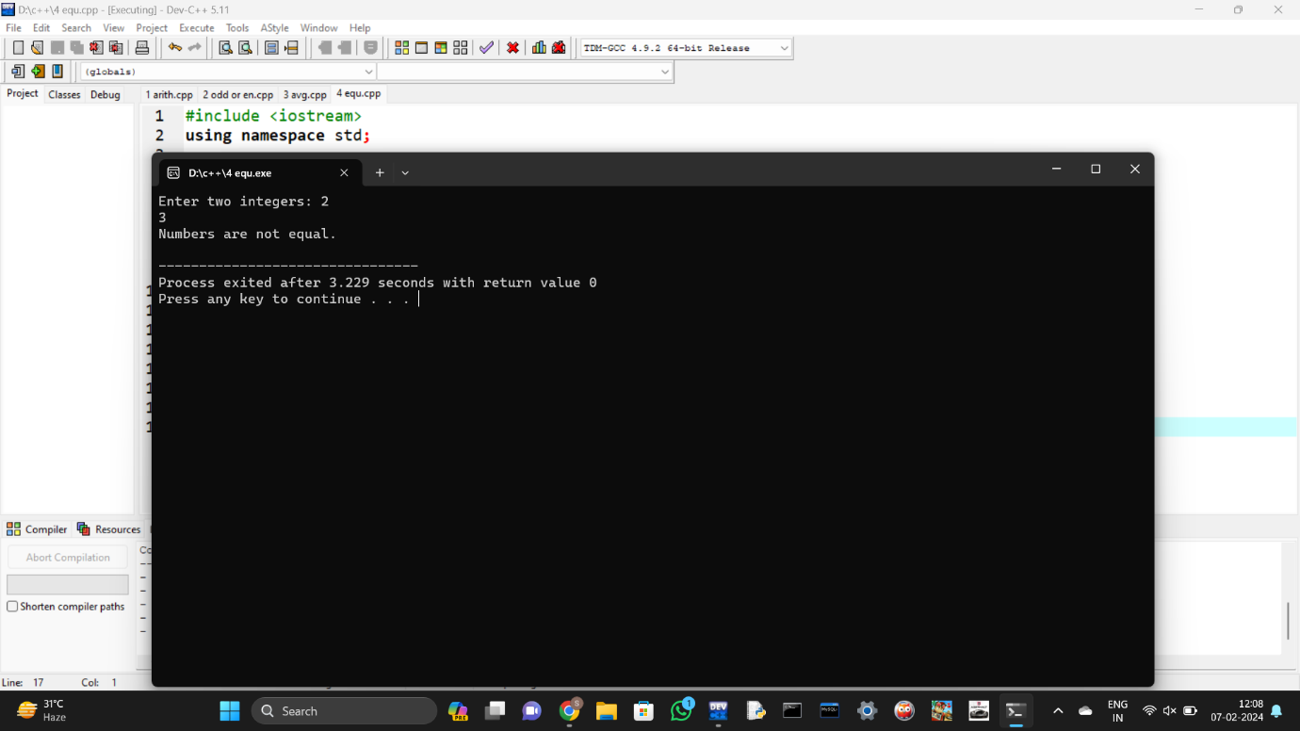

5.

#include <iostream>

using namespace std;

int main() {

float num1, num2;

cout << "Enter two floating-point numbers: ";

cin >> num1 >> num2;

cout << "Addition: " << num1 + num2 << endl;

cout << "Subtraction: " << num1 - num2 << endl;

cout << "Multiplication: " << num1 \* num2 << endl;

if (num2 != 0) {

cout << "Division: " << num1 / num2 << endl;

} else {

cout << "Cannot perform division as the second number is zero." << endl;

}

return 0;}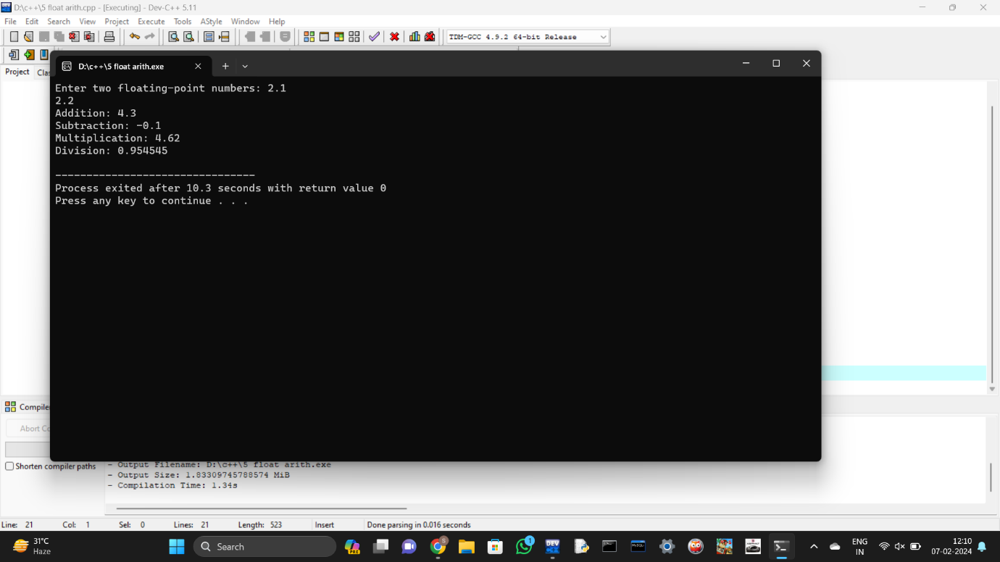

6.

#include <iostream>

using namespace std;

int main() {

char ch;

cout << "Enter a character: ";

cin >> ch;

if (ch == 'a' || ch == 'e' || ch == 'i' || ch == 'o' || ch == 'u' ||

ch == 'A' || ch == 'E' || ch == 'I' || ch == 'O' || ch == 'U') {

cout << ch << " is a vowel." << endl;

} else {

cout << ch << " is a consonant." << endl;

}

return 0;

}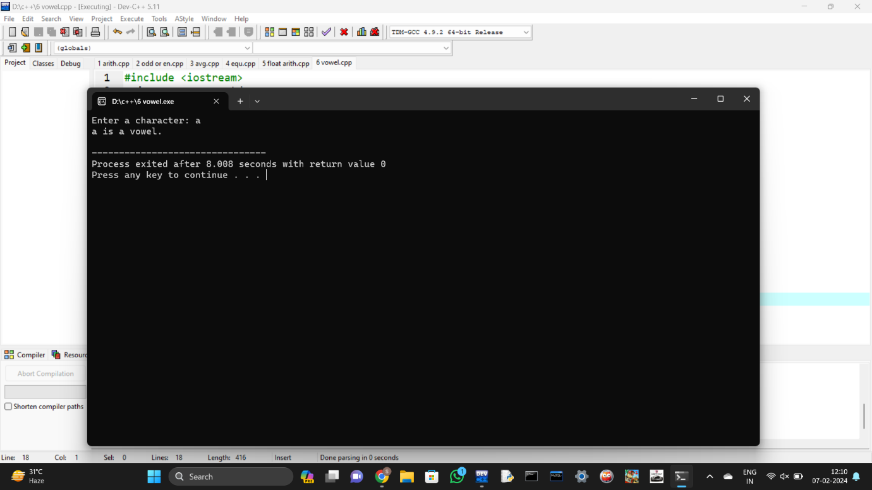

7.

#include <iostream>

using namespace std;

int main() {

int num;

cout << "Enter an integer: ";

cin >> num;

if (num > 0) {

cout << num << " is positive." << endl;

} else if (num < 0) {

cout << num << " is negative." << endl;

} else {

cout << num << " is zero." << endl;

}

return 0;

}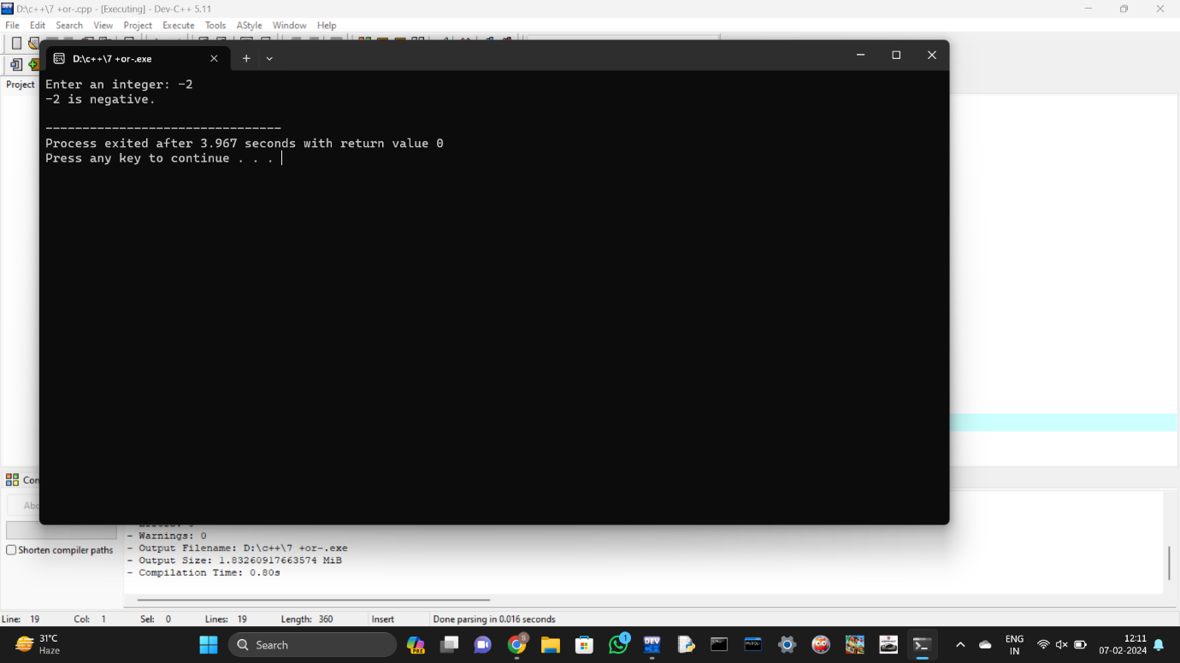

8. #include <iostream>

using namespace std;

int main() {

int num1, num2;

cout << "Enter two integers: ";

cin >> num1 >> num2;

if (num1 > num2) {

cout << num1 << " is greater." << endl;

} else if (num2 > num1) {

cout << num2 << " is greater." << endl;

} else {

cout << "Both numbers are equal." << endl;

}

return 0;

}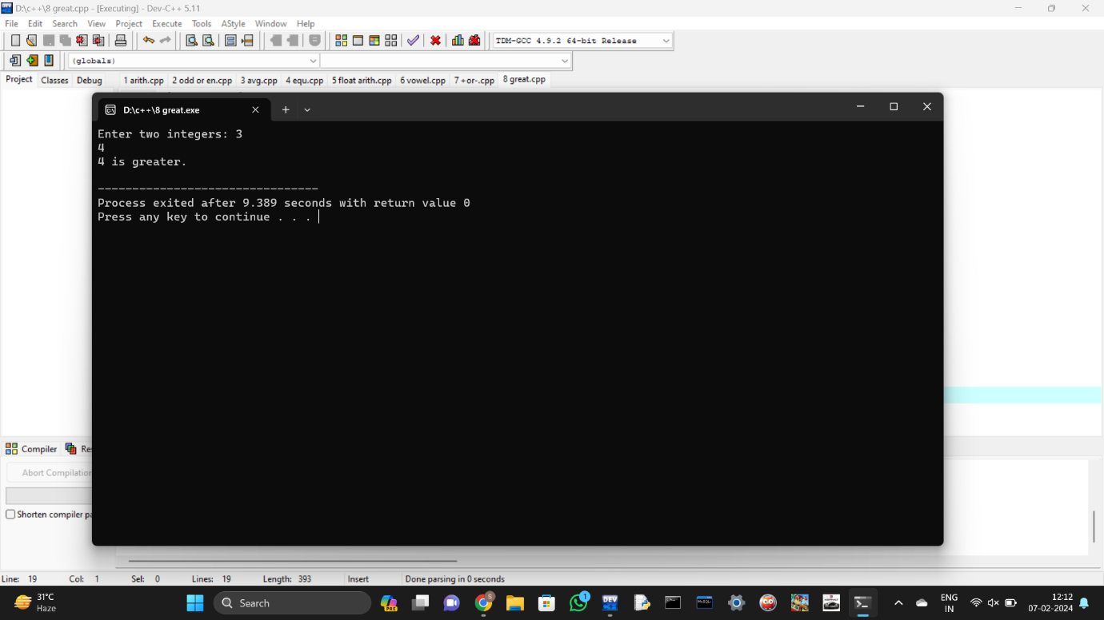

9. #include <iostream>

#include <cmath>

using namespace std;

int main() {

float num;

cout << "Enter a floating-point number: ";

cin >> num;

cout << "Original Number: " << num << endl;

cout << "Rounded to the nearest integer (floor): " << floor(num) << endl;

cout << "Rounded to the nearest integer (ceil): " << ceil(num) << endl;

return 0;

}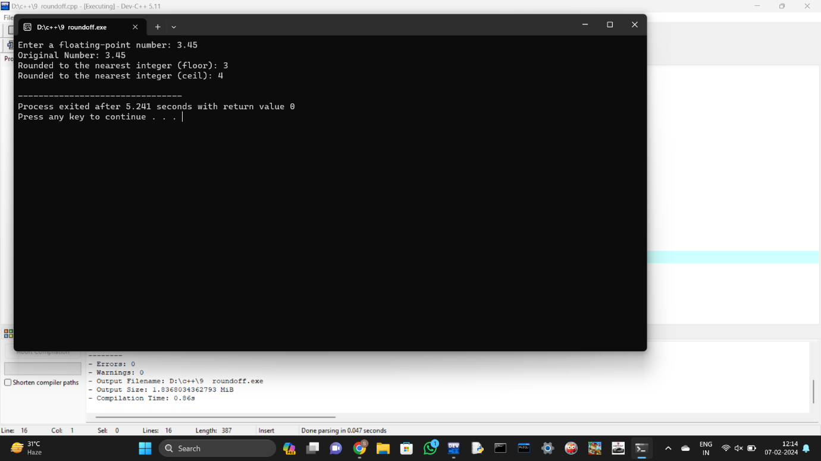

10.

#include <iostream>

using namespace std;

int main() {

int num1, num2;

cout << "Enter two integers: ";

cin >> num1 >> num2;

cout << "Before swapping: num1 = " << num1 << ", num2 = " << num2 << endl;

num1 = num1 ^ num2;

num2 = num1 ^ num2;

num1 = num1 ^ num2;

cout << "After swapping: num1 = " << num1 << ", num2 = " << num2 << endl;

return 0;

}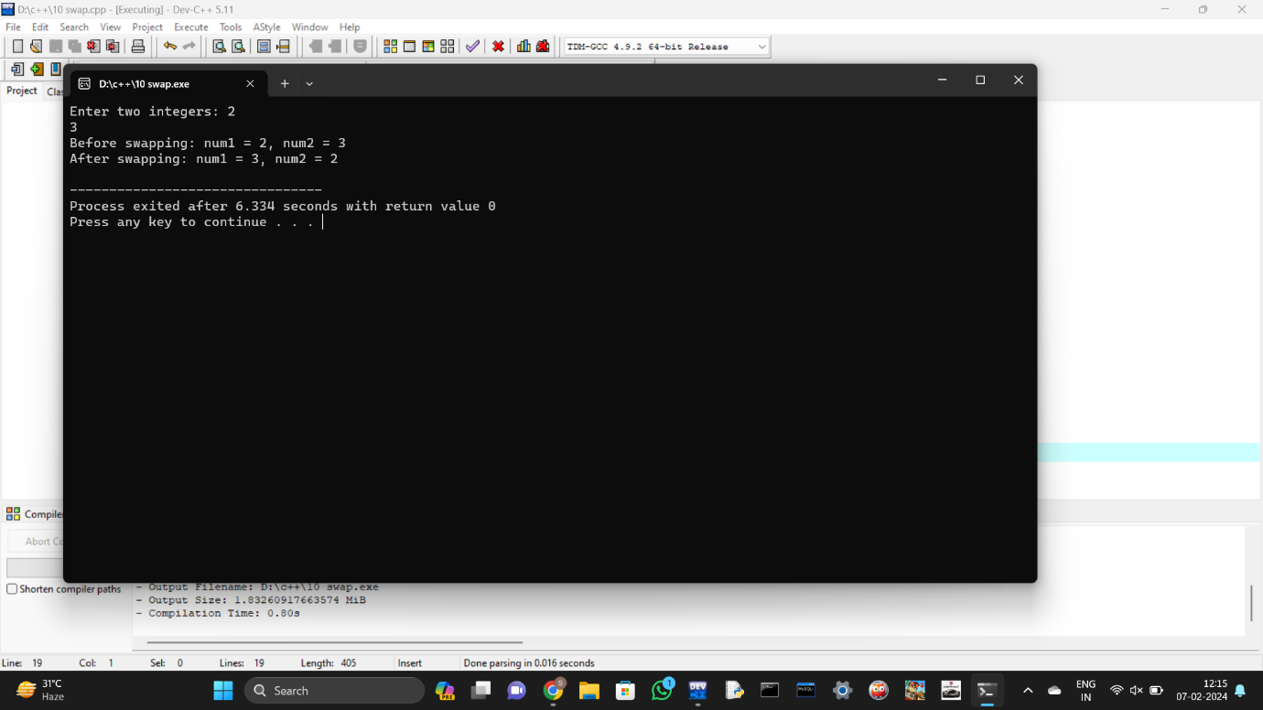

11.

#include <iostream>

using namespace std;

int main() {

int num1, num2, num3;

cout << "Enter three integers: ";

cin >> num1 >> num2 >> num3;

int largest = (num1 > num2) ? (num1 > num3 ? num1 : num3) : (num2 > num3 ? num2 : num3);

cout << "Largest number: " << largest << endl;

return 0;

}

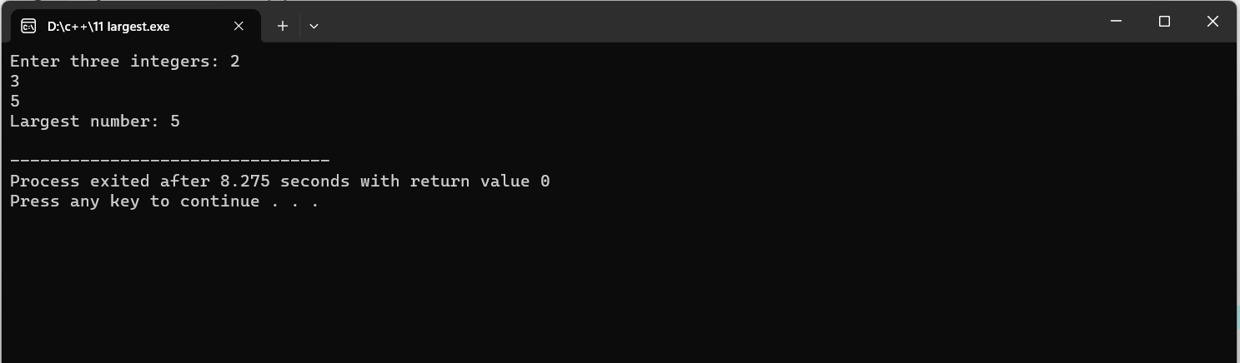

12.

#include <iostream>

using namespace std;

int main() {

int num1, num2;

cout << "Enter two integers: ";

cin >> num1 >> num2;

string result = (num1 == num2) ? "Numbers are equal." : "Numbers are not equal.";

cout << result << endl;

return 0;

}

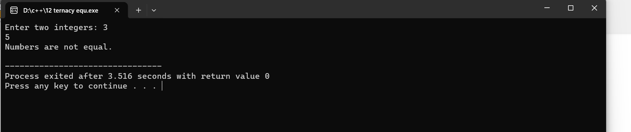

13.

#include <iostream>

using namespace std;

int main() {

int num;

cout << "Enter an integer: ";

cin >> num;

string result = (num % 3 == 0) ? "Divisible by 3." : "Not divisible by 3.";

cout << result << endl;

return 0;

}

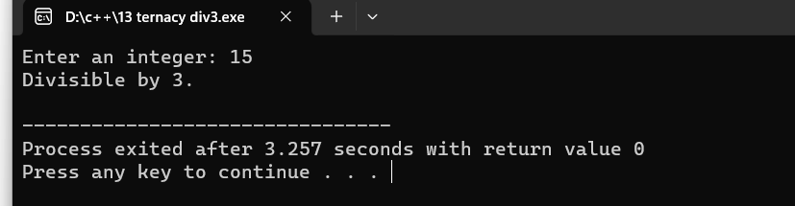

14.

#include <iostream>

using namespace std;

int main() {

cout << "Numbers from 1 to 10: ";

for (int i = 1; i <= 10; ++i) {

cout << i << " ";

}

cout << endl;

return 0;

}

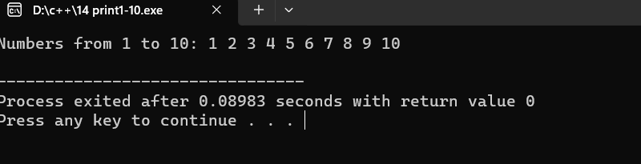

15.

#include <iostream>

using namespace std;

int main() {

int num;

cout << "Enter a number: ";

cin >> num;

int factorial = 1;

for (int i = 1; i <= num; ++i) {

factorial \*= i;

}

cout << "Factorial of " << num << ": " << factorial << endl;

return 0;

}

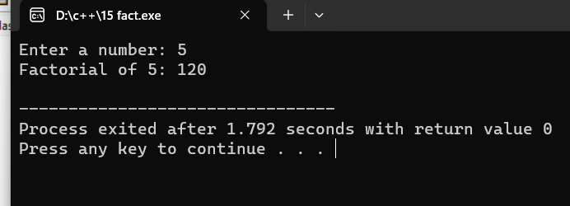

16.

#include <iostream>

using namespace std;

int main() {

int num;

cout << "Enter a number: ";

cin >> num;

cout << "Multiplication table of " << num << ":\n";

for (int i = 1; i <= 12; ++i) {

cout << num << " \* " << i << " = " << num \* i << endl;

}

return 0;

}

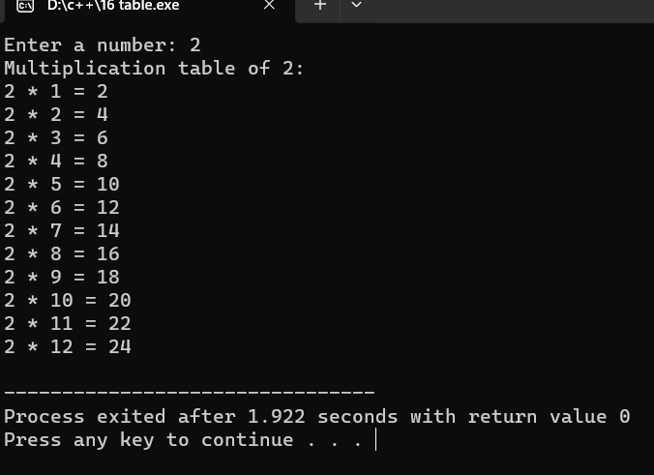

17.

#include <iostream>

using namespace std;

int main() {

int n;

cout << "Enter the number of terms for Fibonacci series: ";

cin >> n;

int first = 0, second = 1, next;

cout << "Fibonacci series:\n";

for (int i = 0; i < n; ++i) {

cout << first << " ";

next = first + second;

first = second;

second = next;

}

cout << endl;

return 0;}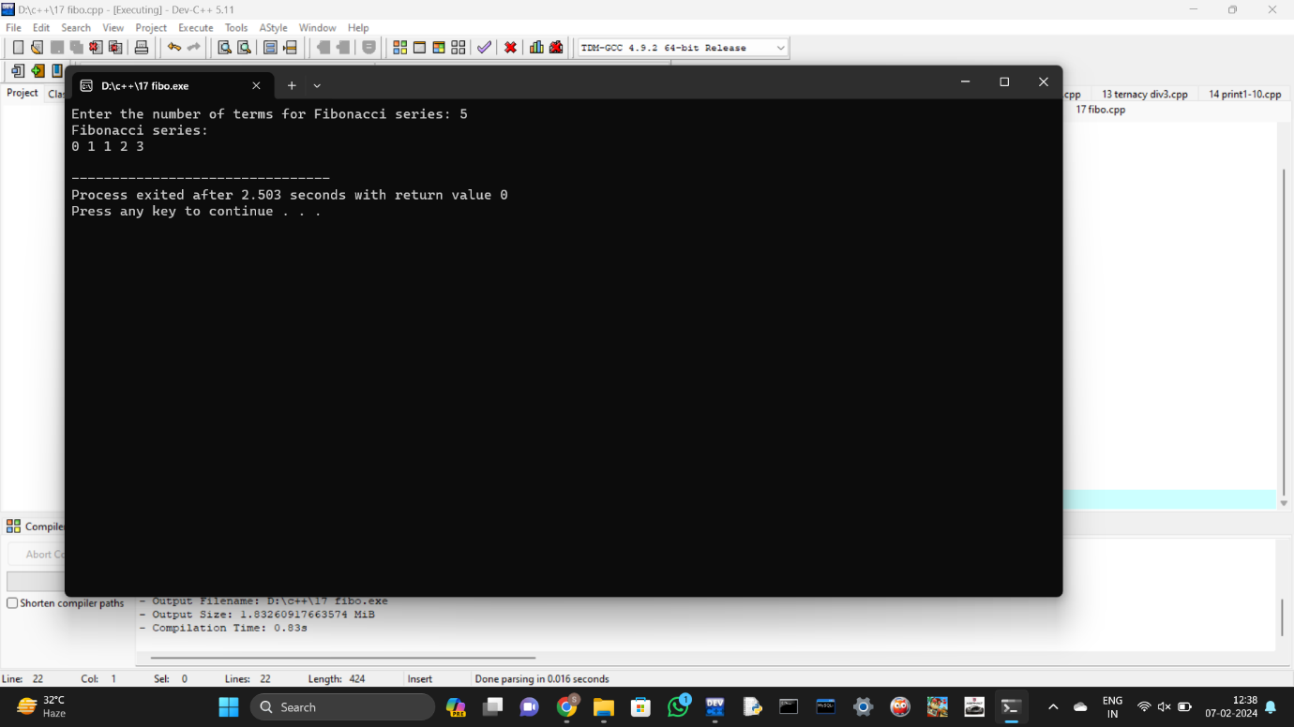

18.

#include <iostream>

#include <cmath>

using namespace std;

int main() {

int num;

cout << "Enter a number: ";

cin >> num;

bool isPrime = true;

if (num <= 1) {

isPrime = false;

} else {

for (int i = 2; i <= sqrt(num); ++i) {

if (num % i == 0) {

isPrime = false;

break;

}

}

}

if (isPrime) {

cout << num << " is a prime number." << endl;

} else {

cout << num << " is not a prime number." << endl;

} return 0;

}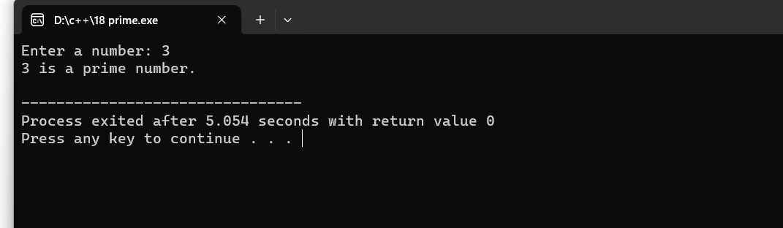

19.

#include <iostream>

#include <cstring>

using namespace std;

int main() {

char str[100];

cout << "Enter a string: ";

cin.getline(str, 100);

int len = strlen(str);

bool isPalindrome = true;

for (int i = 0, j = len - 1; i < j; ++i, --j) {

if (str[i] != str[j]) {

isPalindrome = false;

break;

}

}

if (isPalindrome) {

cout << "The string is a palindrome." << endl;

} else {

cout << "The string is not a palindrome." << endl;

}

return 0;

}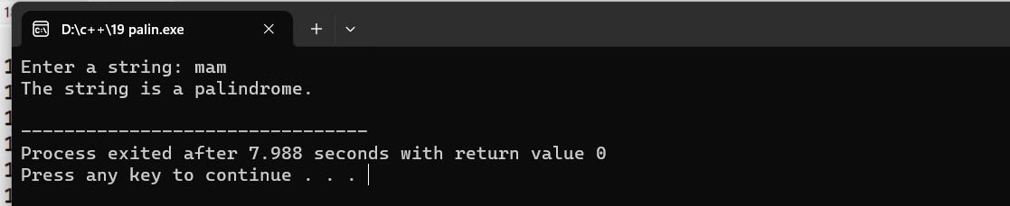

20.

#include <iostream>

using namespace std;

int main() {

int n, sum = 0;

cout << "Enter an integer: ";

cin >> n;

while (n != 0) {

sum += n % 10;

n /= 10;

}

cout << "Sum of digits: " << sum << endl;

return 0;

}